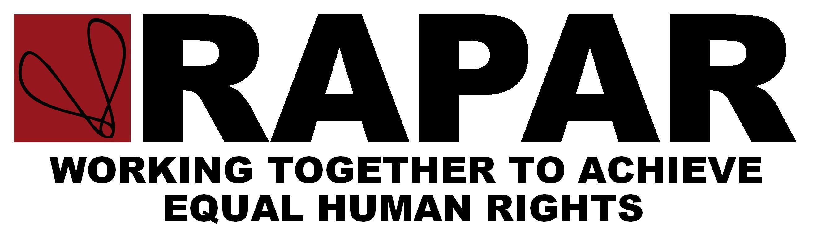
Friends Meeting House
6 Mount Street
Manchester
M2 5NS
Administration Office: 0044-161-834-8221
Fax: 0044-161-6010262
Email: admin@rapar.org.uk
Website: www.rapar.co.uk


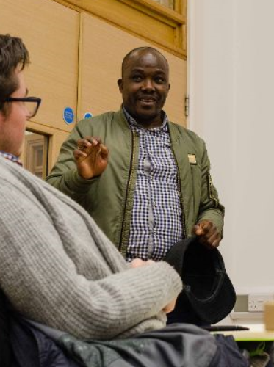

WE NEED NESTOR

Petition to the Home Secretary:

Nestor Sylla came to the UK 12 years ago after fleeing Guinea because of death threats and persecution. This followed the death of his father, the disappearance of his mother and the murder of his sister. He came to the UK to seek safety and has built up close relationships with people in Manchester who he now regards as his family. He has volunteered for many charitable organisations and has been a carer for one of his close friends when she was seriously ill. He also helps look after the children of another close friend. Nestor's immigration case has been caught up in a "whirlpool" of Home Office bureaucracy and unlawful action against him, and the Home Office now wants to remove him from the UK. He has no family, friends or home in Guinea. Nestor's home is now in Manchester and his
new family need him here.
Please sign the petition calling for Nestor to be given leave to remain in the UK. For more
information see http://www.rapar.co.uk/we-need-nestor.html
Please PRINT your name, email and postcode clearly below
NAME EMAIL POSTCODE

